Ruby Assignments

Assignment 1: Print User Details

Task
● Store your name, age, and city in variables
● Print them in a readable sentence
Example Output
My name is Rahul, I am 22 years old and I live in Pune.

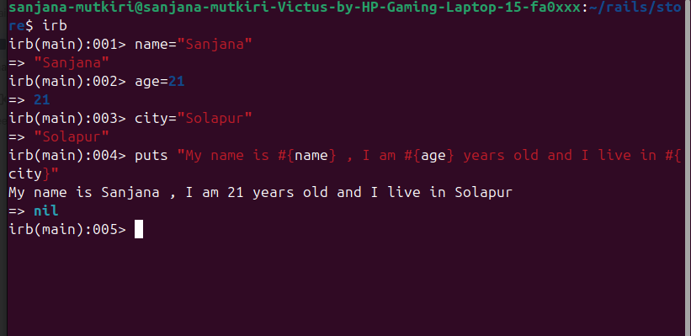

Assignment 2: Count Word Frequency
Task
● Given a sentence

Count how many times each word appears
Example Input
"ruby is easy and ruby is fun"

Expected Output
{ "ruby" => 2, "is" => 2, "easy" => 1, "and" => 1, "fun" => 1 }

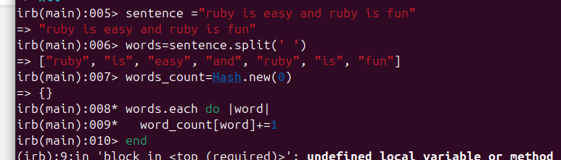

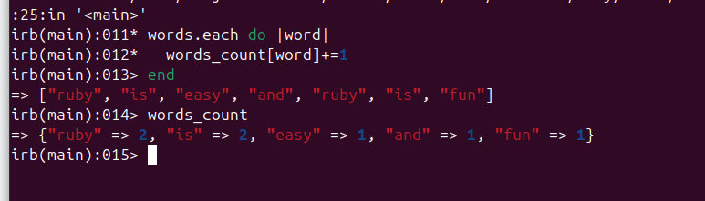

Assignment 3: Classes and Objects – Bank Account
Task
Create a BankAccount class.
Attributes

● account_holder
● balance
Methods
● deposit(amount)
● withdraw(amount)
● show_balance

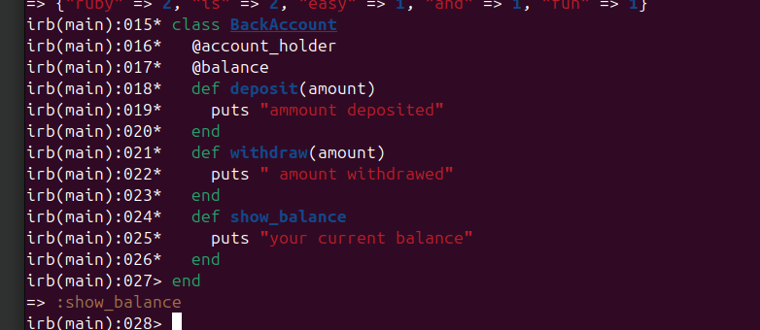

Assignment 4: Ruby Style Fix
Task

● Given messy Ruby code
● Rewrite it following Ruby style guide

Example (Messy Code)
class bankaccount
def initialize(Name,BAL)
@Name=Name
@BAL=BAL
end
def showBalance
puts @Name+" balance is "+@BAL.to_s
end
End

1 Class name should be in CamelCase → BankAccount
2 Method names should be snake_case → show_balance
3 Variable names should be lowercase
4 Adding an example object to see output

Correct Code 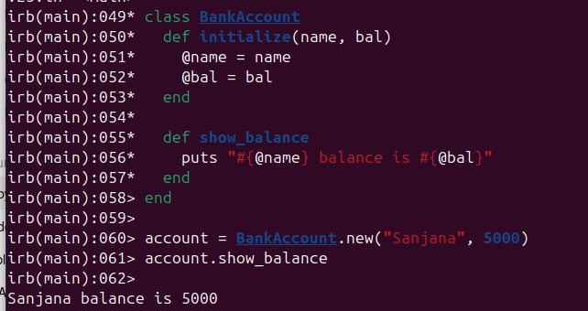

Assignment 5: Conceptual (Theoretical Questions)

Answer the following questions in your own words:

1. Why do we use inheritance?
Inheritance is functionality which allows us to access parent class methods and variable from child class.
Inheritance comes into picture when there is hierarchy of classes(parent—> child )
It gives modularity to code
The piece od code can be reusable
Example :
Class Animal
def speak()
Puts “From Animal class”
end
end
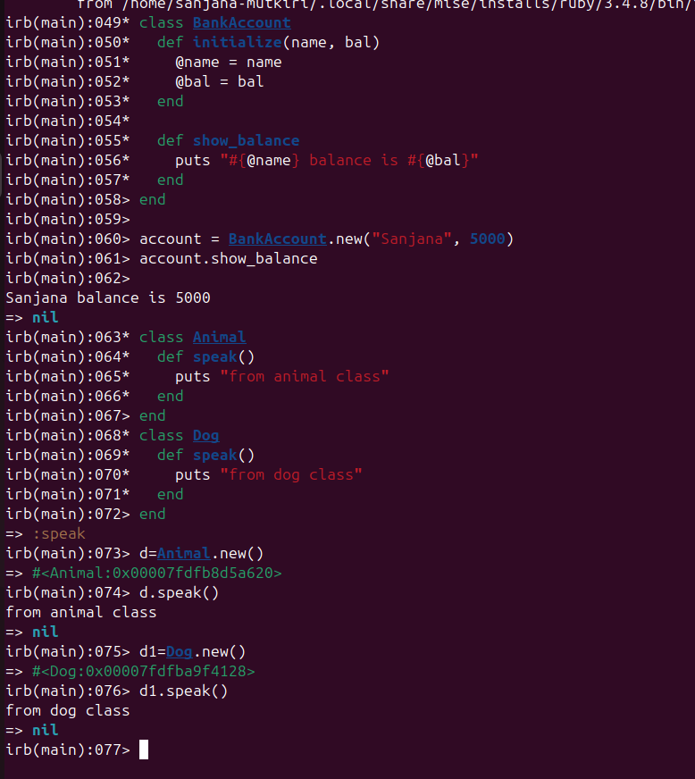

2. Why can’t we create objects from modules?
Modules are collection of different class.
It avoids naming conflicts in projects
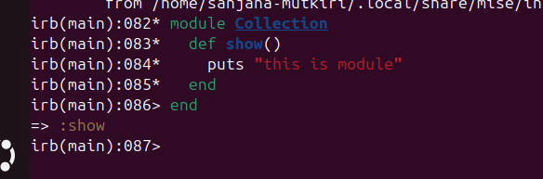

3. What is the difference between include and extend?
In ruby multiple inheritance can be achieved by using keywords include extend and pretend

include
- Adds module methods as instance methods
- Used when objects of a class should use the module methods

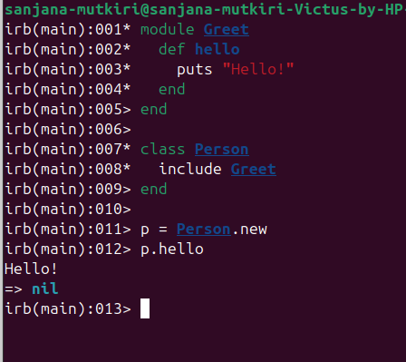

extend
- Adds module methods as class methods
- Used when the class itself should use the module methods
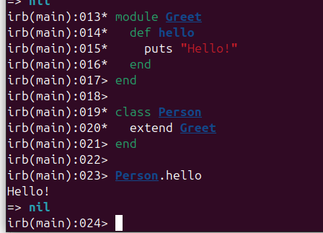

4. When should we use a module instead of a class?

Use a module when:
- You don’t need objects
- You want to share behavior across multiple classes
- You want multiple inheritance (Ruby doesn’t allow multiple class inheritance)
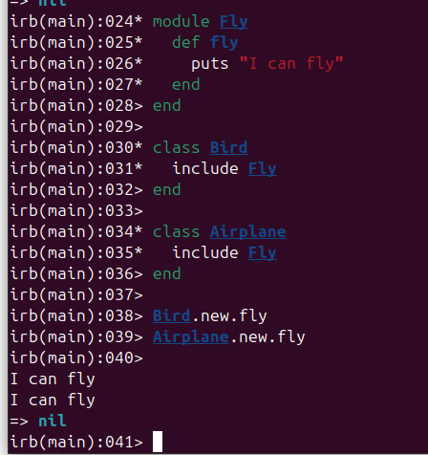

Assignment 6: Employee Management System

Step 1: Create LoggerModule

Modules are used to share common behavior
Logging is a shared utility, not an employee itself

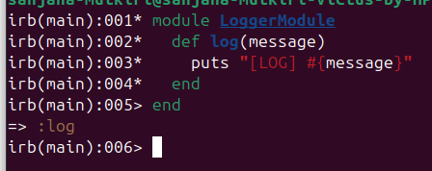
Step 2: Create Base Class Employee
- All employees share name, id, base salary
- Common logic should be in one place
Attributes
- name
- employee_id
- base_salary

Methods
- display_details
- calculate_salary (default)
- log_employee (uses LoggerModule)
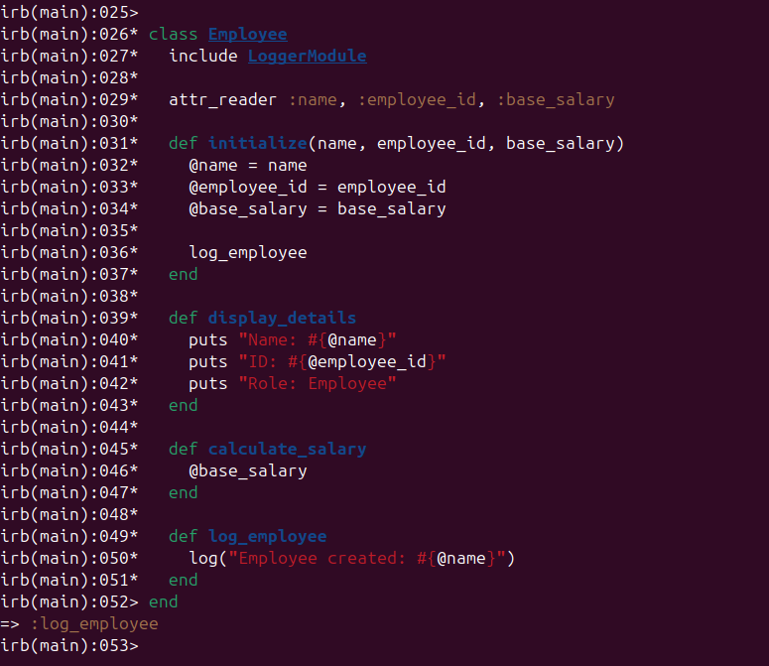

Step 3: Create Developer Class (Inheritance)
Developer IS A Employee → inheritance

Extra attribute
- bonus
Override salary calculation
- base_salary + bonus

Use super
- Reuse parent behavior
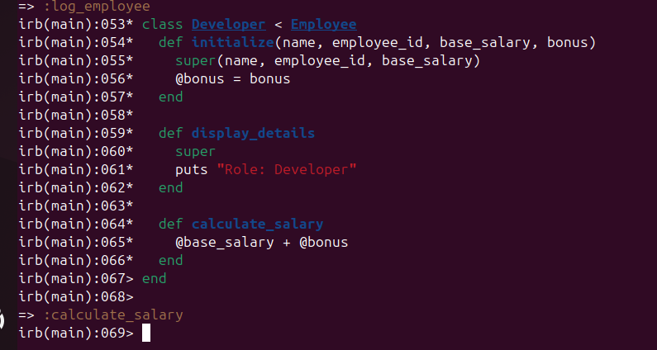

Step 4: Create Manager Class (Inheritance)

Extra attribute
incentive
Salary
base_salary + incentive
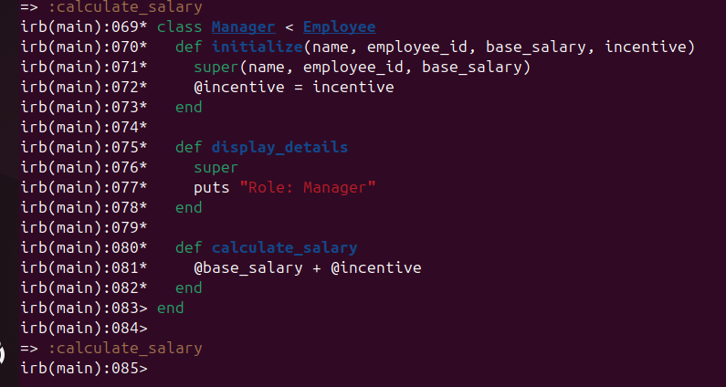

Step 5: Store Employees in an Array

To handle multiple employees
Iterate and display details
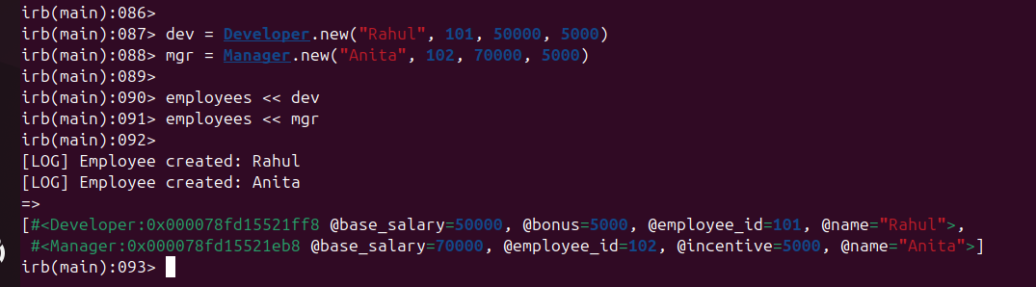

Step 6: Display Details & Salary (Iteration)
